What will you order at Subway?
(information from www.subway.com)

We’re going to Subway on Wednesday, February 28. It’s near the university, at 2507 South King Street. We will walk there together. Let’s get ready by deciding what to order.

Circle what you will order. First, choose one of the following:
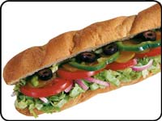

Sub
Go to p. 2

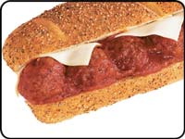

Toasted sub
Go to p. 2

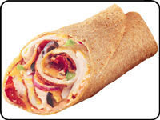
Wrap
Go to p. 2

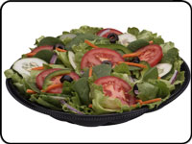
Salad
Go to p. 3
Subs and toasted subs
- Choose the size:
  - 6 inch
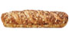
  - Foot long
- Choose the bread:
  - White
  - Wheat
  - Honey oat
  - Roasted garlic
  - Italian herb & cheese
- Subs: go to p. 3
Toasted subs: Choose the kind:
  - Meatball marinara

  - Italian BMT (Genoa salami, pepperoni, and ham)
  - Spicy Italian (pepperoni and salami)
  - Chipotle southwest steak & cheese
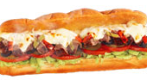
  - Steak & cheese
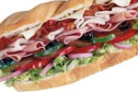

  - Subway Melt (turkey, ham, bacon, and melted cheese)
  - Chicken & bacon ranch
- Go to p. 3

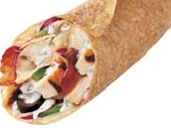
Wraps
- Choose the kind
  - Chicken & Bacon Ranch

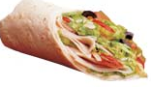
  - Turkey Breast & Bacon Melt

  - Turkey Breast

  - Tuna
- Go to p. 3
Subs and salads
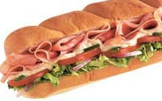
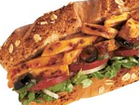
Choose the kind:
- Veggie Delite (vegetables only; no meat)
- Ham
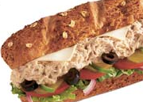
- Turkey breast
- Turkey breast & ham
- Roast beef
- Oven-roasted chicken breast
- Subway Club (turkey breast, roast beef, and ham)
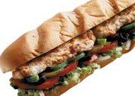
- Sweet onion chicken teriyaki
- Cold cut combo (turkey bologna, turkey ham, and turkey salami)
- Classic tuna (tuna and mayonnaise)

Subs, toasted subs, wraps, and salads
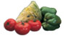
- Choose your vegetables:
  - Lettuce
  - Tomatoes
  - Green peppers
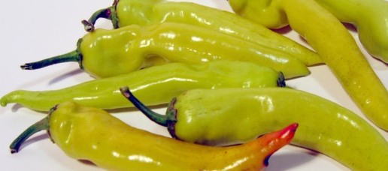
  - Cucumbers
  - Olives
  - Jalapeno peppers
  - Banana peppers
  - Onions
  - Pickles
- Choose your toppings:
  - Cheese
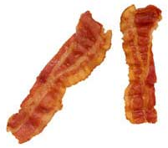
    - American
    - Pepperjack
    - Provolone
  - Bacon
- Choose your condiments:
  - Mustard
  - Mayonnaise
  - Light mayonnaise
  - Olive oil
  - Vinegar
  - Salt
  - Pepper
  - Chipotle southwest sauce
  - Fat free honey mustard
  - Fat free sweet onion dressing
Anything else?

- Cookies
  - Chocolate chip
  - Double chocolate
  - Oatmeal
  - M&M
  - White chocolate macadamia nut
- Drinks (Coke products)
- Soups
  - Chicken noodle
  - Clam chowder
- Chips

Here’s an example of a conversation between a customer and a server at Subway.

Server: Are you ready to order?
Customer: Yes. I’ll have a 6-inch Subway Club on wheat.
S: Do you want cheese?
C: Yes. Provolone.
S: What veggies do you want?
C: Everything except olives.
S: What kind of dressing do you want?
C: Light mayo, salt, and pepper.
S: Is that for here or to go?
C: For here.
S: Anything else?
C: A small drink. And two double chocolate cookies.
S: That’ll be $6.83.
C: Thanks.
Write what you will order. Don’t forget to include all the details!

Server: Are you ready to order?
You: Yes. I’ll have a _________________________________________________
_________________________________________________________________.
(Tell the server if you want a sub, salad, or wrap, what size, and on what kind of bread.)
S: Do you want cheese?
Y: _______________________________________________________________.
(Say “yes” or “no”. If you say “yes”, tell what kind of cheese you want.)
S: What veggies do you want?
Y: _______________________________________________________________.
S: What kind of dressing do you want?
Y: _______________________________________________________________.
S: Is that for here or to go?
Y: _______________________________________________________________.
S: Anything else?
Y: _______________________________________________________________.
S: That’ll be $6.83.
Y: Thanks.

